LifePrint brings photographs to life by embedding video within prints
3 PICTURES
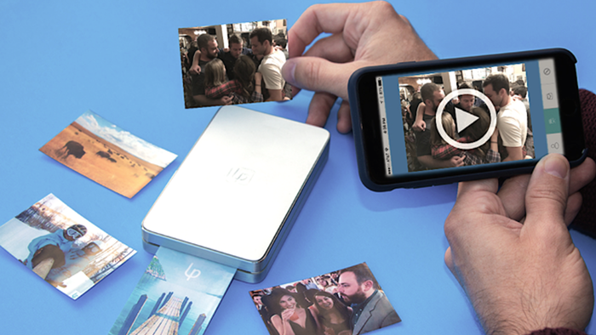

A picture is worth a thousand words, so the saying goes. But how many words is an image that springs to life with sound and moving video when viewed through a mobile device worth? LifePrint has launched a wireless portable printer and companion app, designed to print and share photos enhanced with augmented reality technology.
It's hard to be spontaneous with photo printing when your printer is tethered to a power outlet. The LifePrint printer is designed with pocket-portability in mind, measuring 5 in long, 3 in wide, and 1 in thick (127 x 76 x 25.5 mm), and weighing a mere 7 oz (200 g). The internal battery charges via USB, and a full charge is said to be good for about 10 to 15 prints.
However, things get a lot more interesting when you use the LifePrint app (iOS and Android) to create, share, and view these prints. The mobile app uses the company's unique Hyperphoto technology, which offers users the option to embed video clips within photos. When one looks at the physical print by itself, it's just a regular image, but when viewed through the app (requiring the mobile device's rear-facing camera), it becomes an augmented reality photo that plays up to 15 seconds of video with audio.
And the video doesn't have to be related to the photo at all. Users can get creative with choosing a video to embed, whether the moment is adventurous, cherished, silly, or anything else. Small watermarks can be added in the bottom corner of printed photos to identify which are of the augmented reality kind.

